**Name of School:……………………………………………………………………………**

**Candidate’s Name:……………………………………………………………………………**

**Centre No. /Index No: ………………………………………. Signature:………………**

**P525/1**

**CHEMISTRY**

**Paper 1**

**July - August**

**2 ¾ Hours**



**ELITE EXAMINATION BUREAU MOCK 2019**

**Uganda Advanced Certificate of Education**

**CHEMISTRY**

**Paper 1**

2 Hours 45 Minutes

**INSTRUCTIONS TO CANDIDATES:**

* *This paper consists of* ***two*** *sections* ***A*** *and* ***B.***
* *Section* ***A*** *is compulsory.*
* *Attempt only* ***six*** *questions in section B*
* *Answers must be written in the spaces provided only.*

*(R=0.0821 L.atm.mol-1K-1)*

|  |  |  |  |  |  |  |  |  |  |  |  |  |  |  |  |  |  |
| --- | --- | --- | --- | --- | --- | --- | --- | --- | --- | --- | --- | --- | --- | --- | --- | --- | --- |
| ***For examiner’s use only*** | | | | | | | | | | | | | | | | | ***TOTAL*** |
| **1** | **2** | **3** | **4** | **5** | **6** | **7** | **8** | **9** | **10** | **11** | **12** | **13** | **14** | **15** | **16** | **17** |
|  |  |  |  |  |  |  |  |  |  |  |  |  |  |  |  |  |  |

**SECTION A: (46 marks)**

**Answer all questions from this section.**

1. The standard electrode potentials for some half – cells are shown below.

+0.77V

+0.15V

1. Write the convention for the combined cell. (1½ marks)

……………………………………………………………………………………………………………………………………………………………………………………………………………………

1. Write equation for the:
2. reaction at the cathode (01 mark)

…………………………………………………………………………………………………………………………………………………………………………………………………………

1. reaction at the anode (01 mark)

…………………………………………………………………………………………………………………………………………………………………………………………………………

1. overall cell reaction (1½ marks)

…………………………………………………………………………………………………………………………………………………………………………………………………………

1. Calculate the e.m.f of the cell. (01 mark)

……………………………………………………………………………………………………………………………………………………………………………………………………………………

…………………………………………………………………………………………………………

1. State one application of electrode potentials. (01 mark)

……………………………………………………………………………………………………………………………………………………………………………………………………………………

1. a) Draw the structure and name the shape of the following oxides. In each case state the oxidation state of the Sulphur atom. (02 marks)

|  |  |  |  |
| --- | --- | --- | --- |
| **Oxide** | **Structure** | **Shape** | **Oxidation state of sulphur** |
|  |  |  |  |
|  |  |  |  |

b) i) Name the reagent that can be used to distinguish between the oxides in (a). (01 mark)

……………………………………………………………………………………………………………………………………………………………………………………………………………………

ii) State what would be observed, if a solution of each oxide is treated separately with the reagent you have named in b(i). (01 mark)

…………………………………………………………………………………………………………………………………………………………………………………………………………

iii) Write equation(s) for the reaction(s) that would take place when solutions of each oxides are treated separately with the reagent you have named in b(i). (1½ marks)

…………………………………………………………………………………………………………………………………………………………………………………………………………………………………………………………………………………………………………………………………………………………………………………………………………………………………………………………………………………………………………………………

1. a) Define the term solubility product. (01 mark)

……………………………………………………………………………………………………………………………………………………………………………………………………………………

b) Calculate the solubility product of a solution containing 8.35 x 10-3g of magnesium hydroxide in one litre of solution at 250C. (03marks)

………………………………………………………………………………………………………………………………………………………………………………………………………………………………………………………………………………………………………………………………

………………………………………………………………………………………………………………………………………………………………………………………………………………………………………………………………………………………………………………………………

……………………………………………………………………………………………………………………………………………………………………………………………………………………

c) State one application of solubility product. (01 mark)

……………………………………………………………………………………………………………………………………………………………………………………………………………………

1. a) Write equation for the reaction between water and
2. iron (III) chloride (1½ marks)

………………………………………………………………………………………………………………………………………………………………………………………………………………

1. tin (II) chloride (1½ marks)

………………………………………………………………………………………………………………………………………………………………………………………………………………

b) A piece of clean magnesium ribbon was added to the solution in a(i). State what was observed and write equation for the reaction that took place. (2½ marks)

………………………………………………………………………………………………………………………………………………………………………………………………………………………………………………………………………………………………………………………………

…………………………………………………………………………………………………………

1. Methylamine ionises in water according to the following equation.
   1. Write the expression for the ionization constant Kb of methylamine. (01 mark)

……………………………………………………………………………………………………………………………………………………………………………………………………………………

* 1. 0.2 moles of methyl ammonium chloride was added to one litre of 0.2M methylamine.

1. Calculate the PH of the resultant solution. [The ionization constant Kb of methylamine is 4.4 x 10-4mol l-1, Kw is 1.0 x 10-14 mol2 l-2 at 250C]. (03 marks)

………………………………………………………………………………………………………………………………………………………………………………………………………………………………………………………………………………………………………………………………………………………………………………………………………………………………………………………………………………………………………………………………………………………………………………………………………………………………………………………………

1. State the assumption(s) you have made in b(i). (½ mark)

………………………………………………………………………………………………………………………………………………………………………………………………………………………………………………………………………………………………………………………

1. Write equations to show how the following compounds can be synthesized.
2. CH = N – OH

from benzene (2½ marks)

……………………………………………………………………………………………………………………………………………………………………………………………………………………

……………………………………………………………………………………………………………………………………………………………………………………………………………………………………………………………………………………………………………………………….

1. from ethanol (2½ marks)

………………………………………………………………………………………………………………………………………………………………………………………………………………………………………………………………………………………………………………………………

…………………………………………………………………………………………………………

1. To an aqueous solution of **CoCl2.6H2O** was added concentrated hydrochloric acid dropwise until in excess.
   1. Name:
2. the cobalt species present in the solution before hydrochloric acid was added. (01 mark)

……………………………………………………………………………………………………

1. the cobalt species present in the solution containing excess hydrochloric acid. (01 mark)

……………………………………………………………………………………………………

* 1. The solution containing excess hydrochloric acid was diluted with water

1. State the colour change that took place. (01 mark)

…………………………………………………………………………………………………………………………………………………………………………………………………………

1. Write an equation for the reaction that took place. (1½ mark)

…………………………………………………………………………………………………………………………………………………………………………………………………………

1. a) When propene reacts with bromine in presence of sodium chloride solution, a mixture of a dibromo and bromo chloro compounds are formed. Outline a mechanism for the reaction leading to the formation of the two compounds. (03 marks)

………………………………………………………………………………………………………………………………………………………………………………………………………………………………………………………………………………………………………………………………

………………………………………………………………………………………………………………………………………………………………………………………………………………………………………………………………………………………………………………………………

b) Name the type of mechanism for the reaction in (a).

…………………………………………………………………………………………………………

1. The data below was obtained for the reaction.

A + B Products

|  |  |  |  |
| --- | --- | --- | --- |
| **Experiment** | **Initial concentrations**  **(mol dm-3)** | | **Initial rate**  **mol d m-3 S-1** |
| **A** | **B** |
| 1 | 2.0 | 2.0 | 3.2 x 10-5 |
| 2 | 2.0 | 4.0 | 6.4 x 10-5 |
| 3 | 4.0 | 2.0 | x |
| 4 | 4.0 | 4.0 | 25.6 x 10-5 |

1. Write the rate equation. (01 mark)

………………………………………………………………………………………………………………………………………………………………………………………………………………………………………………………………………………………………………………………………

1. Calculate
2. the value of x (01 mark)

………………………………………………………………………………………………………………………………………………………………………………………………………………

1. the rate constant for the reaction and state its units. (02 marks)

………………………………………………………………………………………………………………………………………………………………………………………………………………………………………………………………………………………………………………………………………………………………………………………………………………………………………………………………………………………………………………………………………

**SECTION B (54 Marks)**

**Answer six questions from this section.**

1. Complete the following equations and write a mechanism for the reaction in each case.
   1. CH3CH2 NHNH2 H+

C = O + (04 marks)

CH3

………………………………………………………………………………………………………………………………………………………………………………………………………………………………………………………………………………………………………………………………

………………………………………………………………………………………………………………………………………………………………………………………………………………………………………………………………………………………………………………………………

* 1. OH

+ CH3COCl (3½ marks)

………………………………………………………………………………………………………………………………………………………………………………………………………………………………………………………………………………………………………………………………

………………………………………………………………………………………………………………………………………………………………………………………………………………………………………………………………………………………………………………………………

* 1. CH3CH2Cl (1½ marks)

……………………………………………………………………………………………………………………………………………………………………………………………………………………………………………………………………………………………………………………………..

………………………………………………………………………………………………………………………………………………………………………………………………………………………………………………………………………………………………………………………………

…………………………………………………………………………………………………………

1. a) State
2. the common oxidation states of manganese. (1½ marks)

………………………………………………………………………………………………………………………………………………………………………………………………………………………………………………………………………………………………………………………………

1. the most stable oxidation state of Manganese. (½ mark)

………………………………………………………………………………………………………………………………………………………………………………………………………………

1. the reason for your answer in a(ii). (½ mark)

………………………………………………………………………………………………………………………………………………………………………………………………………………

b) Write a half equation for the reduction of permanganate ion in

1. acid medium (01 mark)

………………………………………………………………………………………………………………………………………………………………………………………………………………

1. alkaline medium (01 mark)

………………………………………………………………………………………………………………………………………………………………………………………………………………

1. An acidified solution of potassium iodide was added to a solution of potassium permanganate.
2. State what was observed. (01 mark)

………………………………………………………………………………………………………………………………………………………………………………………………………………

1. Write the ionic equation for the reaction that took place. (1½ marks)

………………………………………………………………………………………………………………………………………………………………………………………………………………

1. State
2. two advantages of using potassium permanganate as a reagent in volumetric analysis. (01 mark)

………………………………………………………………………………………………………………………………………………………………………………………………………………………………………………………………………………………………………………………

1. two reasons why potassium permanganate is not a primary standard. (01 marks)

………………………………………………………………………………………………………………………………………………………………………………………………………………………………………………………………………………………………………………………………………………………………………………………………………………………………

1. a) Define the term **“Partition coefficient”**  (01 mark)

………………………………………………………………………………………………………………………………………………………………………………………………………………………………………………………………………………………………………………………………

…………………………………………………………………………………………………………

b) Copper (II) ions forms a complex with ammonia. The table below shows the results of partition of ammonia between 0.1M copper (II) ions and trichloromethane.

|  |  |  |  |  |  |
| --- | --- | --- | --- | --- | --- |
| [NH3] | 0.88 | 1.08 | 1.34 | 1.56 | 1.80 |
| [NH3(CHCl3). | 0.02 | 0.03 | 0.04 | 0.05 | 0.06 |

1. Plot a graph of [NH3] against [NH3(CHCl3). (03 marks)
2. Determine the value of n in the complex. (2½ marks)

………………………………………………………………………………………………………………………………………………………………………………………………………………………………………………………………………………………………………………………

………………………………………………………………………………………………………

1. i) Determine the partition coefficient, KD of ammonia between aqueous copper (II) ions and trichloromethane. (1½ marks)

………………………………………………………………………………………………………………………………………………………………………………………………………………………………………………………………………………………………………………………

………………………………………………………………………………………………………

ii) State what the value of KD you have determined indicates about the distribution of ammonia. (01 mark)

………………………………………………………………………………………………………………………………………………………………………………………………………………………………………………………………………………………………………………………

1. Name a regent that can be used to distinguish between the following pairs of organic compounds and in each case state what is observed.

CH2NH2

CH3

NH2

and (3marks)

Reagent: …………………………………………………………………………………………….

………………………………………………………………………………………………………….

Observation:

……………………………………………………………………………………………………………………………………………………………………………………………………………………………………………………………………………………………………………………………….

b) HCOOH and CH3COOH

Reagent: …………………………………………………………………………………………….

………………………………………………………………………………………………………….

Observation:

……………………………………………………………………………………………………………………………………………………………………………………………………………………………………………………………………………………………………………………………….

CH2Br

CH3

Br

(c)

and

Reagent:

………………………………………………………………………………………………………….

………………………………………………………………………………………………………….

Observation:

………………………………………………………………………………………………………………

………………………………………………………………………………………………………………

………………………………………………………………………………………………………………

1. Carbon, silicon, germanium, tin and lead are in group IV of the periodic table.
2. State;
3. the common oxidation states exhibited by the elements in their ions or compounds. (01 mark)

………………………………………………………………………………………………………………………………………………………………………………………………………………

1. how the stability of each oxidation state in a(i) varies down the group. (01 marks)

………………………………………………………………………………………………………………………………………………………………………………………………………………………………………………………………………………………………………………………

1. Give a reason for your answer in (a) (ii). (01 mark)

……………………………………………………………………………………………………………………………………………………………………………………………………………………

1. Compare the thermal stabilities of carbon tetrachloride and lead tetrachloride (include equations of reactions if any) (2½ marks)

………………………………………………………………………………………………………………………………………………………………………………………………………………………………………………………………………………………………………………………………

…………………………………………………………………………………………………………

1. Describe the reaction if any between each of carbon tetrachloride and lead tetrachloride with water.
2. Carbon tetrachloride (01 marks)

………………………………………………………………………………………………………………………………………………………………………………………………………………………………………………………………………………………………………………………

1. Lead tetrachloride (2½ marks)

………………………………………………………………………………………………………………………………………………………………………………………………………………………………………………………………………………………………………………………

1. State what would be observed and write equation for the reaction that would take place when
   1. Solid sodium iodide is heated with concentrated sulphuric acid. (2½ marks)

………………………………………………………………………………………………………………………………………………………………………………………………………………………………………………………………………………………………………………………………

…………………………………………………………………………………………………………

* 1. A mixture of benzoic acid and iron (III) chloride solution is heated. (02 marks)

………………………………………………………………………………………………………………………………………………………………………………………………………………………………………………………………………………………………………………………………

……………………………………………………………………………………………………………………………………………………………………………………………………………………

* 1. Sodium nitrite was added to acidified potassium dichromate solution. (2½ marks)

………………………………………………………………………………………………………………………………………………………………………………………………………………………………………………………………………………………………………………………………

…………………………………………………………………………………………………………

* 1. A mixture of ethanal and silver nitrate in ammonia solution. (02 marks)

………………………………………………………………………………………………………………………………………………………………………………………………………………………………………………………………………………………………………………………………

1. The conductimetric curve for the titration of ethanoic acid and ammonia solution is given below.

C D

**Conductivity**

A

B

**Volume of ammonia solution**

Explain the shape of the graph. (04 marks)

………………………………………………………………………………………………………………………………………………………………………………………………………………………………………………………………………………………………………………………………

………………………………………………………………………………………………………………………………………………………………………………………………………………………………………………………………………………………………………………………………

…………………………………………………………………………………………………………

b) The molar conductivity of nitric acid, sodium bromoethanoate and sodium nitrate are 421, 89.3 and 121.3 Ω-1cm2 mol-1 respectively at inifinite dilution at 250C. Calculate the:

1. molar conductivity of bromoethanoic acid at infinite dilution.(1½ marks)

………………………………………………………………………………………………………………………………………………………………………………………………………………………………………………………………………………………………………………………………………………………………………………………………………………………………

1. Dissociation constant, Ka, of a 0.1M bromoethanoic acid solution. (The electrolytic conductivity of bromoethanoic acid is 4.38 x 10-3 Ω-1cm-1) (3½ marks)

………………………………………………………………………………………………………………………………………………………………………………………………………………………………………………………………………………………………………………………………………………………………………………………………………………………………………………………………………………………………………………………………………………………………………………………………………………………………………………

1. a) Differentiate between soap and soapless detergents. (02 marks)

………………………………………………………………………………………………………………………………………………………………………………………………………………………………………………………………………………………………………………………………

……………………………………………………………………………………………………………………………………………………………………………………………………………………

b) Write equations to show how a soapless detergent can be prepared from dodecanol, CH3(CH2)10CH2OH. (02 marks)

………………………………………………………………………………………………………………………………………………………………………………………………………………………………………………………………………………………………………………………………

………………………………………………………………………………………………………………………………………………………………………………………………………………………………………………………………………………………………………………………………

…………………………………………………………………………………………………………

c) Explain the cleansing action of soap. (03 marks)

………………………………………………………………………………………………………………………………………………………………………………………………………………………………………………………………………………………………………………………………

………………………………………………………………………………………………………………………………………………………………………………………………………………………………………………………………………………………………………………………………

d) State the advantage and disadvantage of using a soapless detergent instead of soap in washing.

1. Advantage (01 mark)

………………………………………………………………………………………………………………………………………………………………………………………………………………

1. Disadvantage (01 mark)

………………………………………………………………………………………………………………………………………………………………………………………………………………

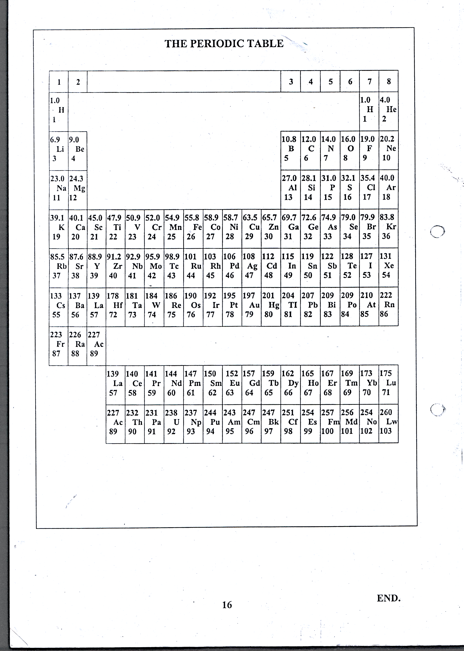

**END**